Chapter 8
Applications: The Costs of Taxation
MULTIPLE CHOICE
1. In 1776, the American Revolution was sparked by anger over
a. the extravagant lifestyle of British royalty.
b. the crimes of British soldiers stationed in the American Colonies.
c. British taxes imposed on the American Colonies.
d. the failure of the British to protect American Colonists from attack by hostile Native Americans.
ANSWER: c. British taxes imposed on the American Colonies.
TYPE: M SECTION: 0 DIFFICULTY: 2
2. In 1776, the American Revolution was sparked by
a. the lack of religious freedom in America.
b. anger over British taxes.
c. Britain’s attempt to control American trade.
d. a select few who craved political power.
ANSWER: b. anger over British taxes.
TYPE: M SECTION: 0 DIFFICULTY: 2
3. When Ronald Reagan ran for the office of President of the United States, he promised that, if elected, he would work for
a. increased taxes on gasoline.
b. reduced state sales tax rates.
c. reduced Federal sales tax rates.
d. reduced Federal income tax rates.
ANSWER: d. reduced Federal income tax rates.
TYPE: M SECTION: 0 DIFFICULTY: 2
4. During Ronald Reagan’s eight years in office
a. income tax rates rose.
b. income tax rates fell.
c. he said, “Read my lips: no new taxes.”
d. the tax rate of high-income taxpayers rose, while the tax rates of low income taxpayers fell.
ANSWER: b. income tax rates fell.
TYPE: M SECTION: 0 DIFFICULTY: 2
5. During Ronald Reagan’s terms in office, the top tax rate fell from
a. 70 percent to 28 percent.
b. 50 percent to 28 percent.
c. 36 percent to 15 percent.
d. 50 percent to 15 percent.
ANSWER: a. 70 percent to 28 percent.
TYPE: M SECTION: 0 DIFFICULTY: 1
6. To fully understand how taxes affect economic well-being, we must
a. assume that economic well-being is not affected if all tax revenue is spent on goods and services for the American public.
b. know the dollar amount of all taxes raised in the country each year.
c. compare the reduced welfare of buyers and sellers to the amount of government revenue raised.
d. compare the expenditures of the 50 state governments with that of the federal government.
ANSWER: c. compare the reduced welfare of buyers and sellers to the amount of government revenue raised.
TYPE: M SECTION: 1 DIFFICULTY: 2
7. To analyze economic well-being in an economy it is necessary to use
a. demand and supply.
b. producer and consumer surplus.
c. government spending and tax revenue.
d. equilibrium price and quantity.
ANSWER: b. producer and consumer surplus.
TYPE: M SECTION: 1 DIFFICULTY: 1
8. When a tax is levied on a good
a. only the quantity of the good sold will change.
b. only the price of the good sold will change.
c. both price and quantity of the good sold will change.
d. neither price nor quantity of the good sold will change.
ANSWER: c. both price and quantity of the good sold will change.
TYPE: M SECTION: 1 DIFFICULTY: 2
9. A tax on a good
a. raises the price buyers pay and lowers the price sellers receive.
b. raises both the price buyers pay and the price sellers receive.
c. lowers both the price buyers pay and the price sellers receive.
d. lowers the price buyers pay and raises the price sellers receive.
ANSWER: a. raises the price buyers pay and lowers the price sellers receive.
TYPE: M SECTION: 1 DIFFICULTY: 3
10. When a good is taxed
a. both buyers and sellers are worse off.
b. only buyers are worse off because they ultimately pay the majority of the tax.
c. only sellers are worse off because the government holds them responsible for collecting the tax.
d. neither buyers nor sellers are worse off since tax revenue is used to provide goods and services that would otherwise not be provided by the market.
ANSWER: a. both buyers and sellers are worse off.
TYPE: M SECTION: 1 DIFFICULTY: 2
11. A tax placed on a product causes the price the buyer pays
a. and the price the seller receives to be higher.
b. and the price the seller receives to be lower.
c. to be lower and the price the seller receives to be higher.
d. to be higher and the price the seller receives to be lower.
ANSWER: d. to be higher and the price the seller receives to be lower.
TYPE: M SECTION: 1 DIFFICULTY: 3
12. Economic analysis uses which of the following to judge the effect of taxes on economic welfare?
a. government spending
b. consumer and producer surplus
c. equilibrium price and quantity
d. opportunity cost
ANSWER: b. consumer and producer surplus
TYPE: M SECTION: 1 DIFFICULTY: 1
13. A tax levied on the supplier of a product shifts the
a. supply curve upward (or to the left).
b. supply curve downward (or to the right).
c. demand curve upward (or to the right).
d. demand curve downward (or to the left).
ANSWER: a. supply curve upward (or to the left).
TYPE: M SECTION: 1 DIFFICULTY: 2
14. A tax levied on the buyers of a product shifts the
a. supply curve upward (or to the left).
b. supply curve downward (or to the right).
c. demand curve downward (or to the left).
d. demand curve upward (or to the right).
ANSWER: c. demand curve downward (or to the left).
TYPE: M SECTION: 1 DIFFICULTY:2
15. If a tax is imposed on the buyer of a product the demand curve would shift
a. downward by the amount of the tax.
b. upward by the amount of the tax.
c. downward by less than the amount of the tax.
d. upward by more than the amount of the tax.
ANSWER: a. downward by the amount of the tax.
TYPE: M SECTION: 1 DIFFICULTY: 2
16. A tax placed on kite buyers will shift
a. demand upward, causing both the price received by sellers and the equilibrium quantity to fall.
b. demand downward, causing both the price received by sellers and the equilibrium quantity to fall.
c. supply downward, causing the price received by sellers to fall and equilibrium quantity to rise.
d. supply upward, causing the price received by sellers to rise and equilibrium quantity to fall.
ANSWER: b. demand downward, causing both the price received by sellers and the equilibrium quantity to fall.
TYPE: M SECTION: 1 DIFFICULTY: 3
17. Buyers of a product will pay the majority of a tax placed on a product when
a. the tax is placed on the seller of the product.
b. the demand is more elastic than supply.
c. supply is more elastic than demand.
d. the tax is placed on the buyer of the product.
ANSWER: c. supply is more elastic than demand.
TYPE: M SECTION: 1 DIFFICULTY: 3
18. If a tax is imposed on a market with elastic demand and inelastic supply,
a. buyers will bear most of the burden of the tax.
b. sellers will bear most of the burden of the tax.
c. the burden of the tax will be shared equally between buyers and sellers.
d. it is impossible to determine how the burden of the tax will be shared.
ANSWER: b. sellers will bear most of the burden of the tax.
TYPE: M SECTION: 1 DIFFICULTY: 3
19. Suppose a tax is imposed on the buyers of a product. The burden of the tax will fall
a. entirely on the buyers.
b. entirely on the sellers.
c. entirely on the government.
d. on both the buyers and the sellers.
ANSWER: d. on both the buyers and the sellers.
TYPE: M SECTION: 1 DIFFICULTY: 2
20. Whether a tax is levied on the buyer or seller of the good does not matter because
a. sellers always bear the full burden of the tax.
b. buyers always bear the full burden of the tax.
c. buyers and sellers will share the burden of the tax.
d. sellers bear the full burden if the tax is levied on them, and buyers bear the full burden if the tax is levied on them.
ANSWER: c. buyers and sellers share the burden of the tax.
TYPE: M SECTION: 2 DIFFICULTY: 2
21. A tax imposed on a market with an inelastic demand and an elastic supply will cause
a. sellers to pay the majority of the tax.
b. buyers to pay the majority of the tax.
c. the tax burden to be equally divided between buyers and sellers.
d. the tax burden to be divided, but it cannot be determined how.
ANSWER: b. buyers to pay the majority of the tax.
TYPE: M SECTION: 1 DIFFICULTY: 3
22. When a tax is placed on the buyers of orange juice, the
a. size of the orange juice market is reduced.
b. price of orange juice decreases.
c. supply of orange juice decreases.
d. price of orange juice increases, and the equilibrium quantity of orange juice is unchanged.
ANSWER: a. size of the orange juice market is reduced.
TYPE: M SECTION: 2 DIFFICULTY: 2
23. One result of a tax, whether the tax is placed on the buyer or the seller, is that the
a. size of the market is reduced.
b. price the seller receives is higher.
c. supply curve will shift upward.
d. demand curve will shift upward.
ANSWER: a. size of the market is reduced.
TYPE: M SECTION: 1 DIFFICULTY: 2
24. When a tax is placed on the buyer of a product the result is that buyers pay
a. less and sellers receive more.
b. less and sellers receive less.
c. more and sellers receive more.
d. more and sellers receive less.
ANSWER: d. more and sellers receive less.
TYPE: M SECTION: 1 DIFFICULTY: 2
25. When a tax is levied on a good
a. neither buyers nor sellers are worse off.
b. sellers are worse off but not buyers.
c. buyers are worse off but not sellers.
d. both buyers and sellers are worse off.
ANSWER: d. both buyers and sellers are worse off.
TYPE: M SECTION: 1 DIFFICULTY: 2
26. What is true about the burden of a tax imposed on gasoline?
a. Buyers bear the entire burden of the tax.
b. Sellers bear the entire burden of the tax.
c. Buyers and sellers share the burden of the tax.
d. The government bears the entire burden of the tax.
ANSWER: c. Buyers and sellers share the burden of the tax.
TYPE: M SECTION: 1 DIFFICULTY: 2
27. A tax placed on chocolate will
a. reduce the equilibrium price of chocolate and increase the equilibrium quantity.
b. increase the equilibrium price of chocolate and reduce the equilibrium quantity.
c. increase the equilibrium price of chocolate and increase the equilibrium quantity.
d. reduce the equilibrium price of chocolate and reduce the equilibrium quantity.
ANSWER: b. increase the equilibrium price of chocolate and reduce the equilibrium quantity.
TYPE: M SECTION: 1 DIFFICULTY: 3
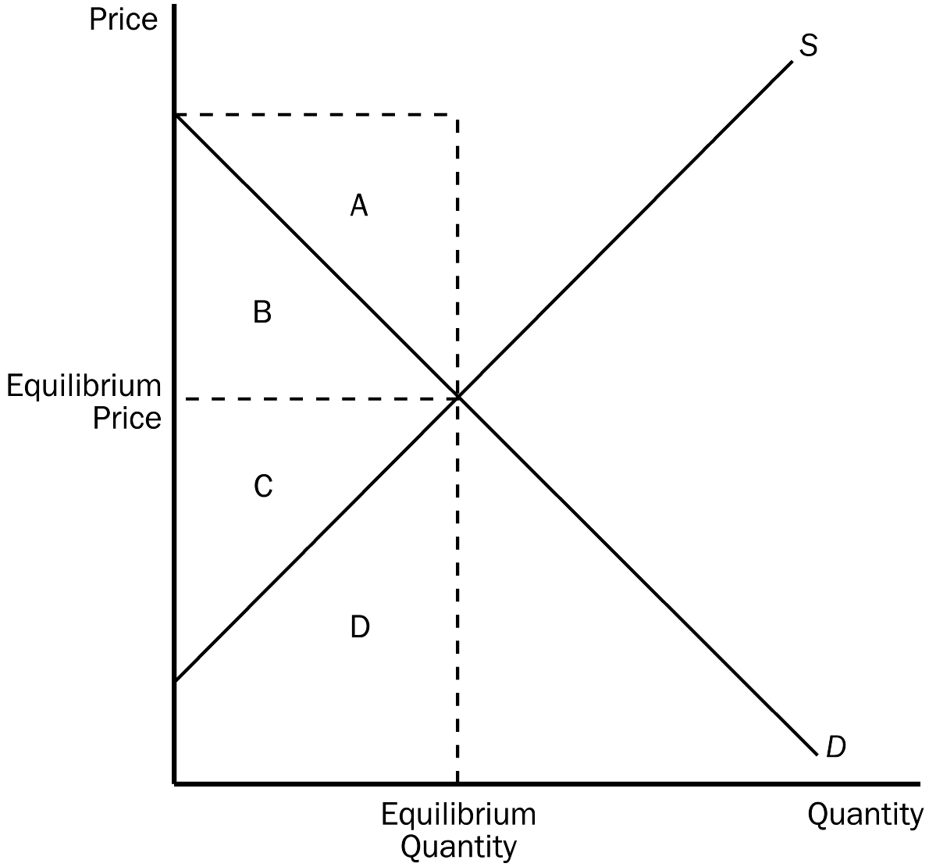
28. According to the graph, if the market is in equilibrium, consumer surplus is represented by area
a. A.
b. B.
c. C.
d. D.
ANSWER: b. B.
TYPE: M SECTION: 1 DIFFICULTY: 1
29. According to the graph, when the market is in equilibrium, producer surplus is represented by area
a. A.
b. B.
c. C.
d. D.
ANSWER: c. C.
TYPE: M SECTION: 1 DIFFICULTY: 1
30. According to the graph, total economic surplus would be represented by area
a. A + B.
b. B + C.
c. C + D.
d. A + D.
ANSWER: b. B + C.
TYPE: M SECTION: 1 DIFFICULTY: 2
31. When a tax is levied on the sellers of a good, the supply curve
a. shifts left (up) by less than the tax.
b. shifts left (up) by more than the tax.
c. shifts left (up) by an amount equal to the tax.
d. does not shift when a tax is levied on sellers.
ANSWER: c. shifts left (up) by an amount equal to the tax.
TYPE: M SECTION: 1 DIFFICULTY: 2
32. When a tax is levied on the sellers of a good, the supply curve shifts
a. up by the amount of the tax.
b. down by the amount of the tax.
c. up by more than the tax.
d. down by less than the tax.
ANSWER: a. up by the amount of the tax.
TYPE: M SECTION: 1 DIFFICULTY: 2
33. A $2.00 tax placed on the sellers of potting soil will shift the supply curve
a. right (downward) by exactly $2.00.
b. left (upward) by less than $2.00.
c. left (upward) by exactly $2.00.
d. right (downward) by less than $2.00.
ANSWER: c. left (upward) by exactly $2.00.
TYPE: M SECTION: 1 DIFFICULTY: 2
34. Which of the following is the most correct statement about tax burdens?
a. A tax burden falls most heavily on the side of the market that is elastic.
b. A tax burden falls most heavily on the side of the market that is inelastic.
c. A tax burden falls most heavily on the side of the market that is closer to unit elastic.
d. A tax burden is distributed independently of relative elasticities of supply and demand.
ANSWER: b. A tax burden falls most heavily on the side of the market that is inelastic.
TYPE: M SECTION: 1 DIFFICULTY: 3
35. When a tax on a good is enacted,
a. buyers and sellers share the burden of the tax regardless of who it is levied on.
b. buyers always bear the full burden of the tax.
c. sellers always bear the full burden of the tax.
d. sellers bear the full burden if the tax is levied on them, but buyers bear the full burden if the tax is levied on them.
ANSWER: a. buyers and sellers share the burden of the tax regardless of who it is levied on.
TYPE: M SECTION: 1 DIFFICULTY: 3
36. A tax placed on a good
a. causes the price of the good to fall.
b. affects buyers of the good, but not sellers.
c. causes the size of the market for the good to shrink.
d. is usually borne entirely by the seller of the good.
ANSWER: c. causes the size of the market for the good to shrink.
TYPE: M SECTION: 1 DIFFICULTY: 2
37. When a tax is levied on a good
a. the market price falls because demand declines.
b. the market price falls because supply falls.
c. a wedge is placed between the price buyers pay and the price sellers receive.
d. the market price rises because demand falls.
ANSWER: c. a wedge is placed between the price buyers pay and the price sellers receive.
TYPE: M SECTION: 1 DIFFICULTY: 2
38. The benefit received by buyers in the market is measured by
a. the demand curve.
b. consumer surplus.
c. the amount buyers are willing to pay for the good.
d. the equilibrium price.
ANSWER: b. consumer surplus.
TYPE: M SECTION: 1 DIFFICULTY: 1
39. The benefit received by the government from a tax is measured by
a. deadweight loss.
b. tax revenue.
c. equilibrium price.
d. total surplus.
ANSWER: b. tax revenue.
TYPE: M SECTION: 1 DIFFICULTY: 1
40. Total tax revenue received by government can be expressed as
a. T/Q.
b. T + Q.
c. T(Q).
d. T – Q.
ANSWER: c. T(Q).
TYPE: M SECTION: 1 DIFFICULTY: 2
41. The benefit received by sellers in a market is measured by
a. the supply curve.
b. producer surplus.
c. the amount sellers receive for their product.
d. the sellers’ cost.
ANSWER: b. producer surplus.
TYPE: M SECTION: 1 DIFFICULTY: 1
42. The benefit from a tax is measured by the
a. benefit received by those people who gain from government’s expenditure of the tax revenue.
b. cost of collecting (administering) the tax.
c. interest saved because the government did not borrow the funds.
d. government’s surplus, which is tax revenue minus government expenditures.
ANSWER: a. benefit received by those people who gain from government’s expenditure of the tax revenue.
TYPE: M SECTION: 1 DIFFICULTY: 2
43. When the government places a tax on a product
a. the cost of the tax to buyers and sellers will be less than the revenue raised from the tax by the government.
b. the cost of the tax to buyers and sellers will equal the revenue raised from the tax by the government.
c. the cost of the tax to buyers and sellers exceeds the revenue raised from the tax by the government.
d. without additional information, such as the elasticity of demand for this product, it is impossible to compare tax cost with tax revenue.
ANSWER: c. the cost of the tax to buyers and sellers exceeds the revenue raised from the tax by the government.
TYPE: M SECTION: 1 DIFFICULTY: 3
44. When a tax is imposed on a good we know that the losses to buyers and sellers
a. are equal to the revenue raised by the government.
b. are less than the revenue raised by the government.
c. exceed the revenue raised by the government.
d. cannot be compared to the tax revenue raised by the government since the amount of the tax will vary from good to good.
ANSWER: c. exceed the revenue raised by the government.
TYPE: M SECTION: 1 DIFFICULTY: 3
45. When a tax is imposed on a product quantity demanded
a. will increase and quantity supplied will decrease.
b. will decrease and quantity supplied will increase.
c. and quantity supplied will both increase.
d. and quantity supplied will both decrease.
ANSWER: d. and quantity supplied will both decrease.
TYPE: M SECTION: 1 DIFFICULTY: 2
46. Deadweight loss measures the
a. loss in a market to buyers and sellers that is not offset by an increase in government revenue.
b. loss in revenue to the government when buyers choose to buy less of the product.
c. loss of efficiency in a market as a result of government intervention.
d. lost revenue to businesses because of higher prices to consumers from the tax.
ANSWER: a. loss in a market to buyers and sellers that is not offset by an increase in government revenue.
TYPE: M SECTION: 1 DIFFICULTY: 2
47. The loss in total surplus resulting from a tax is called
a. a deficit.
b. economic loss.
c. deadweight loss.
d. inefficiency.
ANSWER: c. deadweight loss.
TYPE: M SECTION: 1 DIFFICULTY: 1
48. Deadweight loss is the
a. reduction in total surplus that results from a tax.
b. loss of profit to businesses when a tax is imposed.
c. reduction in consumer surplus when a tax is placed on buyers.
d. decline in government revenue when taxes are reduced in a market.
ANSWER: a. reduction in total surplus that results from a tax.
TYPE: M SECTION: 1 DIFFICULTY: 1
49. A tax has a deadweight loss because
a. it induces the government to spend more.
b. it induces buyers to consume less and sellers to produce less.
c. it causes a disequilibrium in the market.
d. the loss to buyers is greater than the loss to sellers.
ANSWER: b. it induces buyers to consume less and sellers to produce less.
TYPE: M SECTION: 1 DIFFICULTY: 2
50. When evaluating the size of the deadweight loss due to a tax we know that the
a. greater the elasticities of supply and demand, the greater the deadweight loss.
b. smaller the elasticities of supply and demand, the greater the deadweight loss.
c. smaller the decrease in both quantity demanded and quantity supplied, the greater the deadweight loss.
d. primary factor that determines the size of the deadweight loss in the percentage the tax is of price.
ANSWER: a. greater the elasticities of supply and demand, the greater the deadweight loss.
TYPE: M SECTION: 1 DIFFICULTY: 2
51. The amount of deadweight loss that will result from a tax is determined by the
a. price elasticity of demand and supply.
b. number of buyers of the product in the market.
c. number of suppliers of the product in the market.
d. percentage of the purchase price the tax amounts to.
ANSWER: a. price elasticity of demand and supply.
TYPE: M SECTION: 2 DIFFICULTY: 2
52. The larger the deadweight loss of taxation the
a. more people will choose to not buy the product.
b. more the burden of the tax will fall on the buyer and not the seller.
c. more the burden of the tax will fall on the seller and not the buyer.
d. larger the cost of any government program.
ANSWER: d. larger the cost of any government program.
TYPE: M SECTION: 2 DIFFICULTY: 2
53. Assume that the demand for pretzels is relatively inelastic and that the demand for potato chips is relatively elastic. If the same percentage tax were placed on both goods, the tax on which product would create a larger deadweight loss?
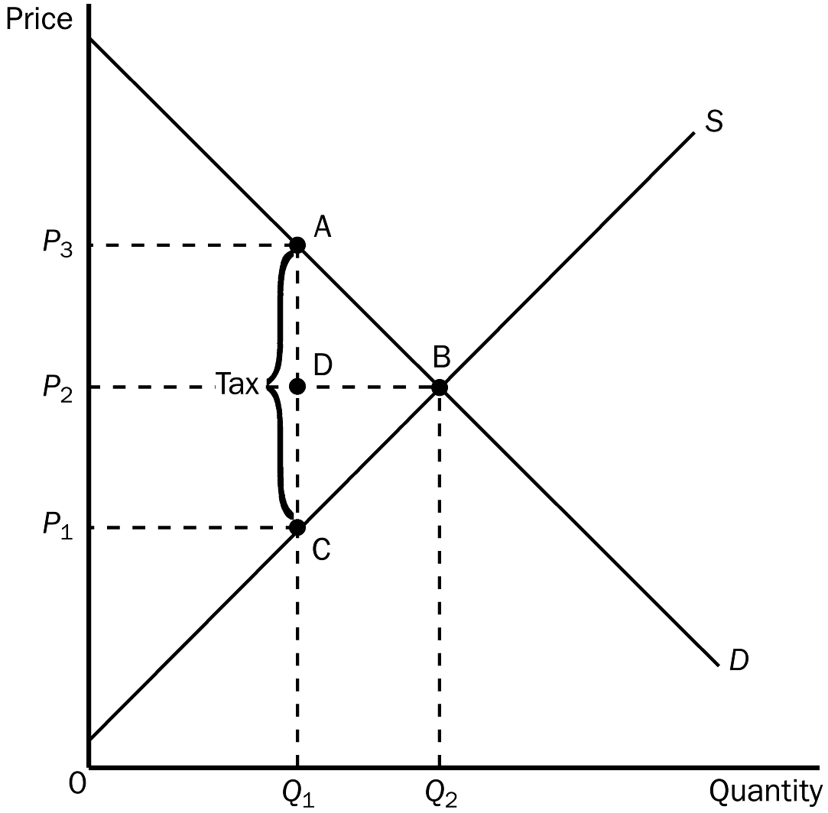
a. the tax on pretzels
b. the tax on potato chips
c. The taxes would create the same amount of deadweight loss.
d. This question is impossible to answer without knowing the price of both pretzels and potato chips.
ANSWER: b. the tax on potato chips
TYPE: M SECTION: 2 DIFFICULTY:2
54. In the graph shown, the equilibrium price before the tax is
a. P₁.
b. P₂.
c. P₃.
d. None of the above are correct.
ANSWER: b. P₂.
TYPE: M SECTION: 2 DIFFICULTY: 2
55. In the graph shown, the price that will be paid after the tax is
a. P₁.
b. P₂.
c. P₃.
d. impossible to determine.
ANSWER: c. P₃.
TYPE: M SECTION: 2 DIFFICULTY: 2
56. In the graph shown, the price sellers receive after the tax is
a. P₁.
b. P₂.
c. P₃.
d. impossible to determine.
ANSWER: a. P1.
TYPE: M SECTION: 2 DIFFICULTY: 2
57. In the graph shown, the per unit burden of the tax on buyers is
a. P₃ – P₁.
b. P₃ – P₂.
c. P₂ – P₁.
d. Q₂ – Q₁.
ANSWER: b. P₃ – P₂.
TYPE: M SECTION: 2 DIFFICULTY: 3
58. In the graph shown, the per unit burden of the tax on the sellers is
a. P₃ – P₁.
b. P₃ – P₂.
c. P₂ – P₁.
d. Q₂ – Q₁.
ANSWER: c. P₂ – P₁.
TYPE: M SECTION: 2 DIFFICULTY: 3
59. In the graph shown, the amount of the tax imposed is
a. P₃ – P₁.
b. P₃ – P₂.
c. P₂ – P₁.
d. Q₂ – Q₁.
ANSWER: a. P₃ – P₁.
TYPE: M SECTION: 2 DIFFICULTY: 3
60. The amount of tax revenue received by the government is equal to the area
a. P₃ A C P₁.
b. A B C.
c. P₂ D A P₃.
d. P₁ C D P₂.
ANSWER: a. P₃ A C P₁.
TYPE: M SECTION: 2 DIFFICULTY: 3
61. The amount of deadweight loss associated with the tax is equal to
a. P₃ A C P₁.
b. A B C.
c. P₂ A D P₃.
d. P₁ D C P₂.
ANSWER: b. A B C.
TYPE: M SECTION: 2 DIFFICULTY: 3

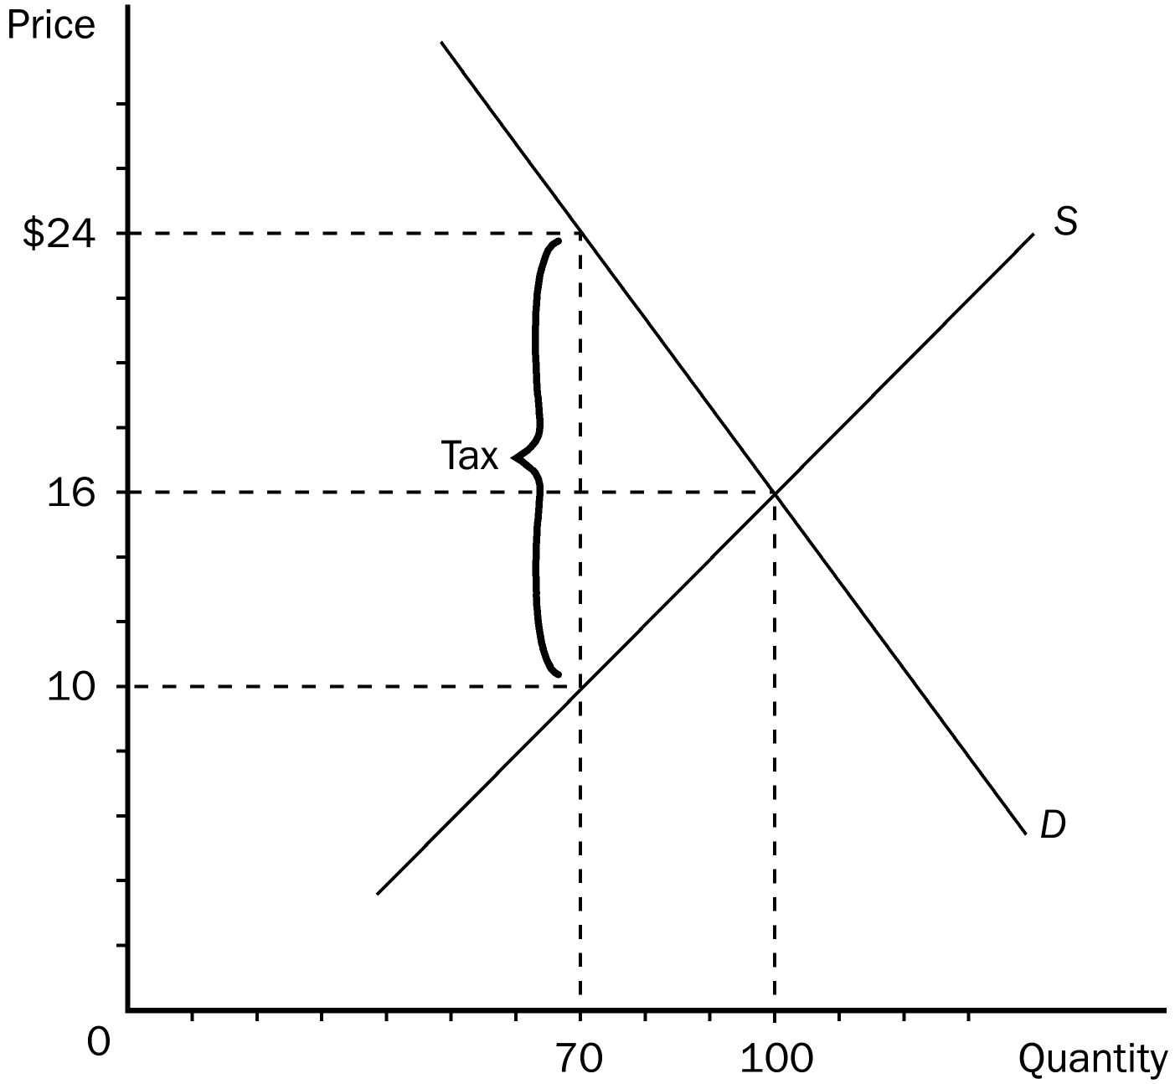
62. In the graph shown, the equilibrium price before the tax is
a. $24.
b. $16.
c. $10.
d. $8.
ANSWER: b. $16.
TYPE: M SECTION: 2 DIFFICULTY: 1
63. In the graph shown, the price that will be paid after the tax is
a. $24.
b. $16.
c. $10.
d. $8.
ANSWER: a. $24.
TYPE: M SECTION: 2 DIFFICULTY: 3
64. In the graph shown, the price sellers receive after the tax is
a. $24.
b. $14.
c. $10.
d. $8.
ANSWER: c. $10.
TYPE: M SECTION: 2 DIFFICULTY: 2
65. In the graph shown, the per unit burden of the tax on buyers is
a. $16.
b. $14.
c. $8.
d. $6.
ANSWER: c. $8.
TYPE: M SECTION: 2 DIFFICULTY: 3
66. In the graph shown, the per unit burden of the tax on the sellers is
a. $16.
b. $14.
c. $8.
d. $6.
ANSWER: d. $6
TYPE: M SECTION: 2 DIFFICULTY: 3
67. In the graph shown, the amount of the tax imposed is
a. $16.
b. $14.
c. $8.
d. $6.
ANSWER: b. $14
TYPE: M SECTION: 2 DIFFICULTY: 3
68. The amount of tax revenue received by the government is equal to
a. $210.
b. $420.
c. $560.
d. $980.
ANSWER: d. $980.
TYPE: M SECTION: 2 DIFFICULTY: 3
69. The amount of deadweight loss as a result of the tax would be equal to
a. $210.
b. $420.
c. $560.
d. $980.
ANSWER: a. $210.
TYPE: M SECTION: 2 DIFFICULTY: 3

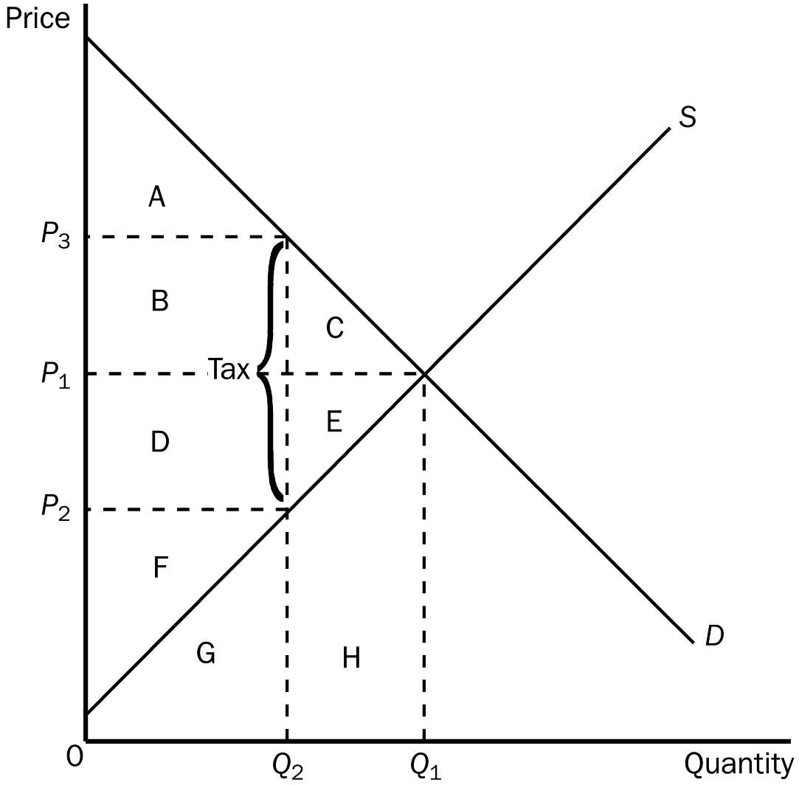
70. According to the graph, the equilibrium market price before the tax is imposed is:
a. P₁.
b. P₂.
c. P₃.
d. impossible to determine.
ANSWER: a. P1.
TYPE: M SECTION: 1 DIFFICULTY: 1
71. According to the graph, the price buyers pay after the tax is
a. P₁.
b. P₂.
c. P₃.
d. impossible to determine.
ANSWER: c. P₃.
TYPE: M SECTION: 1 DIFFICULTY: 2
72. According to the graph, the price sellers receive after the tax is
a. P₁.
b. P₂.
c. P₃.
d. impossible to determine.
ANSWER: b. P₂.
TYPE: M SECTION: 1 DIFFICULTY: 2
73. According to the graph, consumer surplus before the tax was levied is represented by area
a. A.
b. A + B + C.
c. D + E + F.
d. F.
ANSWER: b. A + B + C.
TYPE: M SECTION: 1 DIFFICULTY: 2
74. According to the graph, producer surplus before the tax is represented by area
a. A.
b. A + B + C.
c. D + E + F.
d. F.
ANSWER: c. D + E + F.
TYPE: M SECTION: 1 DIFFICULTY: 2
75. According to the graph, after the tax is levied, consumer surplus is represented by area
a. A.
b. A + B + C.
c. D + E + F.
d. F.
ANSWER: a. A.
TYPE: M SECTION: 1 DIFFICULTY: 2
76. According to the graph, after the tax is levied, producer surplus is represented by area
a. A.
b. A + B + C.
c. D + E + F.
d. F.
ANSWER: d. F.
TYPE: M SECTION: 1 DIFFICULTY: 2
77. According to the graph, the tax caused a reduction in consumer surplus represented by area
a. A.
b. B + C.
c. D + E.
d. F.
ANSWER: b. B + C.
TYPE: M SECTION: 1 DIFFICULTY: 2
78. According to the graph, the tax caused a reduction in producer surplus represented by area
a. A.
b. B + C.
c. D + E.
d. F.
ANSWER: c. D + E.
TYPE: M SECTION: 1 DIFFICULTY: 2
79. According to the graph, the benefits to the government (total tax revenue) is represented by area
a. A + B.
b. B + D.
c. D + F.
d. C + E.
ANSWER: b. B + D.
TYPE: M SECTION: 1 DIFFICULTY: 2
80. According to the graph, the total surplus (consumer, producer, and government) with the tax is represented by area
a. A + B + C.
b. D + E + F.
c. A + B + D + F.
d. C + E.
ANSWER: c. A + B + D + F.
TYPE: M SECTION: 1 DIFFICULTY: 2
81. According to the graph, the loss in total welfare resulting from the levying of the tax is represented by area
a. A + B + C.
b. D + E + F.
c. A + B + D + F.
d. C + E.
ANSWER: d. C + E.
TYPE: M SECTION: 1 DIFFICULTY: 2
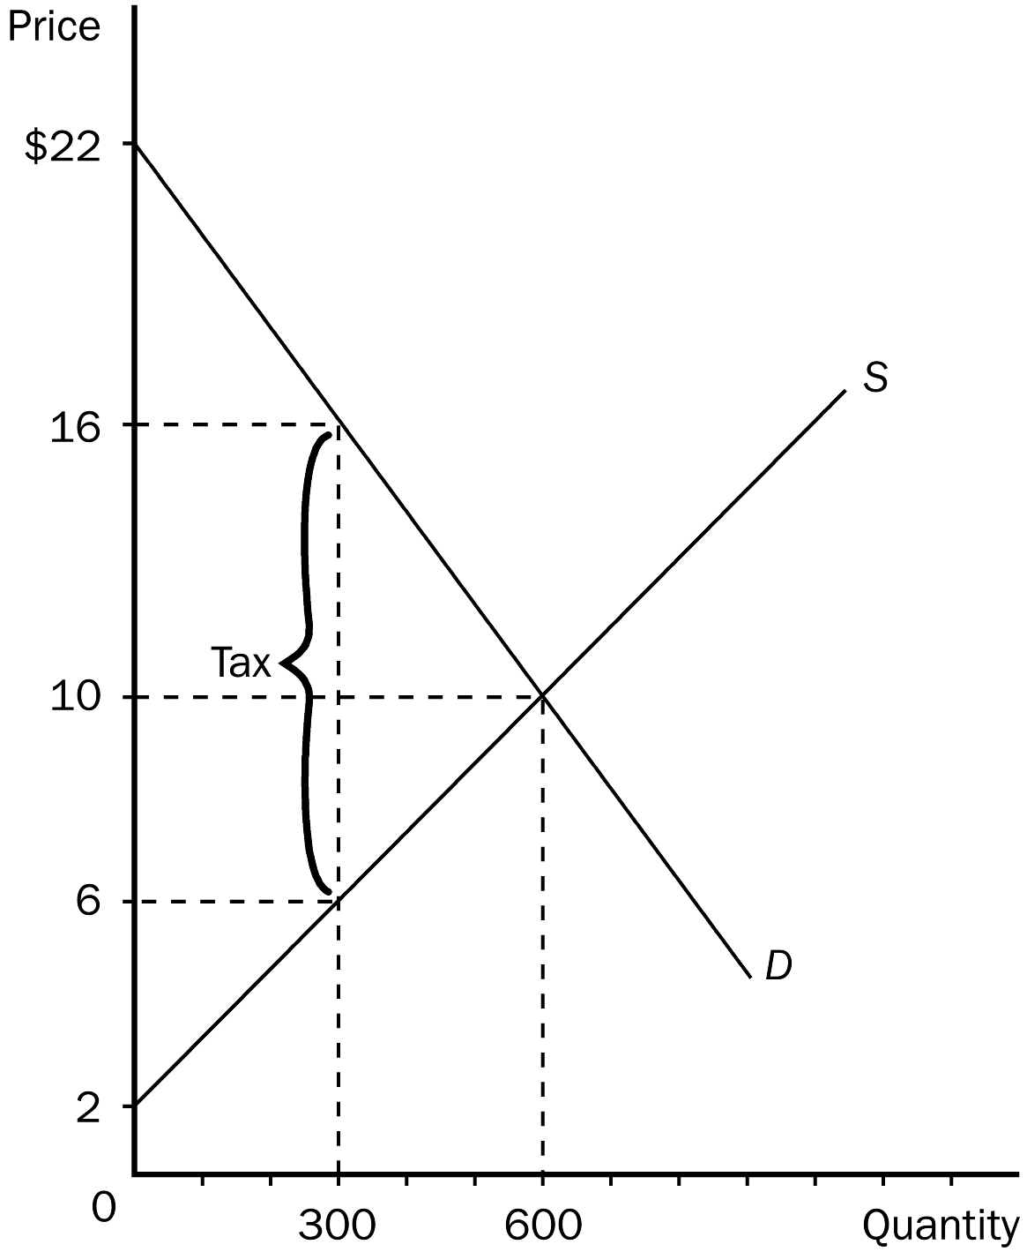
82. According to the graph, without a tax, the equilibrium price and quantity would be
a. $16 and 300.
b. $10 and 600.
c. $10 and 300.
d. $6 and 300.
ANSWER: b. $10 and 600.
TYPE: M SECTION: 1 DIFFICULTY: 1
83. According to the graph, without a tax, consumer surplus in this market would be
a. $1500.
b. $2400.
c. $3000.
d. $3600.
ANSWER: d. $3600.
TYPE: M SECTION: 1 DIFFICULTY: 3
84. According to the graph, without a tax, producer surplus in this market would be
a. $1500.
b. $2400.
c. $3000.
d. $3600.
ANSWER: b. $2400.
TYPE: M SECTION: 1 DIFFICULTY: 3
85. According to the graph, without a tax, total surplus in this market would be
a. $2400.
b. $3000.
c. $3600.
d. $6000.
ANSWER: d. $6000.
TYPE: M SECTION: 1 DIFFICULTY: 3
86. According to the graph, if a tax is imposed in this market, the price buyers would now pay for the good would be
a. $2.
b. $6.
c. $10.
d. $16.
ANSWER: d. $16.
TYPE: M SECTION: 1 DIFFICULTY: 2
87. According to the graph, if a tax is imposed in this market, the price sellers would receive for their product would be
a. $2.
b. $6.
c. $10.
d. $16.
ANSWER: b. $6.
TYPE: M SECTION: 1 DIFFICULTY: 2
88. According to the graph, if a tax is imposed in this market, consumer surplus would be
a. $600.
b. $900.
c. $1500.
d. $3000.
ANSWER: b. $900.
TYPE: M SECTION: 1 DIFFICULTY: 3
89. According to the graph, if a tax is imposed in this market, producer surplus would be
a. $600.
b. $900.
c. $1500.
d. $3000.
ANSWER: a. $600.
TYPE: M SECTION: 1 DIFFICULTY: 3
90. According to the graph, when a tax is placed on this good, the quantity sold will
a. stay at 600 and buyers will still pay $10.
b. fall to 300, but buyers will still pay $10.
c. stay at 600, but buyers will now pay $16.
d. fall to 300, and buyers will now pay $16.
ANSWER: d. fall to 300, and buyers will now pay $16.
TYPE: M SECTION: 1 DIFFICULTY: 3
91. According to the graph, if the government imposes a tax in this market, tax revenue will be
a. $600.
b. $900.
c. $1500.
d. $3000.
ANSWER: d. $3000.
TYPE: M SECTION: 1 DIFFICULTY: 3
92. According to the graph, the amount of the tax placed on this product is
a. $4.
b. $6.
c. $8.
d. $10.
ANSWER: d. $10.
TYPE: M SECTION: 1 DIFFICULTY: 2
93. According to the graph, total surplus with a tax imposed in this market would be
a. $1500.
b. $3600.
c. $4500.
d. $6000.
ANSWER: c. $4500.
TYPE: M SECTION: 1 DIFFICULTY: 3
94. According to the graph, what would happen to consumer surplus if a tax were imposed in this market?
a. It would fall by $3600.
b. It would fall by $2700.
c. It would fall by $1800.
d. It would fall by $900.
ANSWER: b. It would fall by $2700.
TYPE: M SECTION: 1 DIFFICULTY: 3
95. According to the graph, what would happen to producer surplus if a tax were imposed in this market?
a. It would fall by $600.
b. It would fall by $900.
c. It would fall by $1800.
d. It would fall by $2400.
ANSWER: c. It would fall by $1800.
TYPE: M SECTION: 1 DIFFICULTY: 3
96. According to the graph, what would happen to total surplus in this market if a tax were imposed?
a. It would fall by $1500.
b. It would increase by $1500.
c. It would fall by $3000.
d. It would increase by $3000.
ANSWER: a. It would fall by $1500.
TYPE: M SECTION: 1 DIFFICULTY: 3
97. According to the graph, if a tax is imposed in this market, total surplus would fall by
a. $1500.
b. $1800.
c. $2700.
d. $3000.
ANSWER: a. $1500.
TYPE: M SECTION: 1 DIFFICULTY: 3
98. According to the graph, the deadweight loss in this market as a result of a tax would be
a. $600.
b. $900.
c. $1500.
d. $1800.
ANSWER: c. $1500.
TYPE: M SECTION: 1 DIFFICULTY: 3
99. The area between the supply and demand curves up to the equilibrium quantity represents
a. consumer surplus.
b. producer surplus.
c. total surplus.
d. tax revenue.
ANSWER: c. total surplus.
TYPE: M SECTION: 1 DIFFICULTY: 1
100. Total surplus without a tax is equal to
a. consumer surplus and producer surplus.
b. consumer surplus minus producer surplus.
c. consumer surplus, producer surplus, and total surplus.
d. consumer surplus, producer surplus, and tax revenue.
ANSWER: a. consumer surplus and producer surplus.
TYPE: M SECTION: 1 DIFFICULTY: 2
101. Total surplus with a tax is equal to
a. consumer surplus and producer surplus.
b. consumer surplus minus producer surplus.
c. consumer surplus, producer surplus, and total surplus.
d. consumer surplus, producer surplus, and tax revenue.
ANSWER: d. consumer surplus, producer surplus, and tax revenue.
TYPE: M SECTION: 1 DIFFICULTY: 1

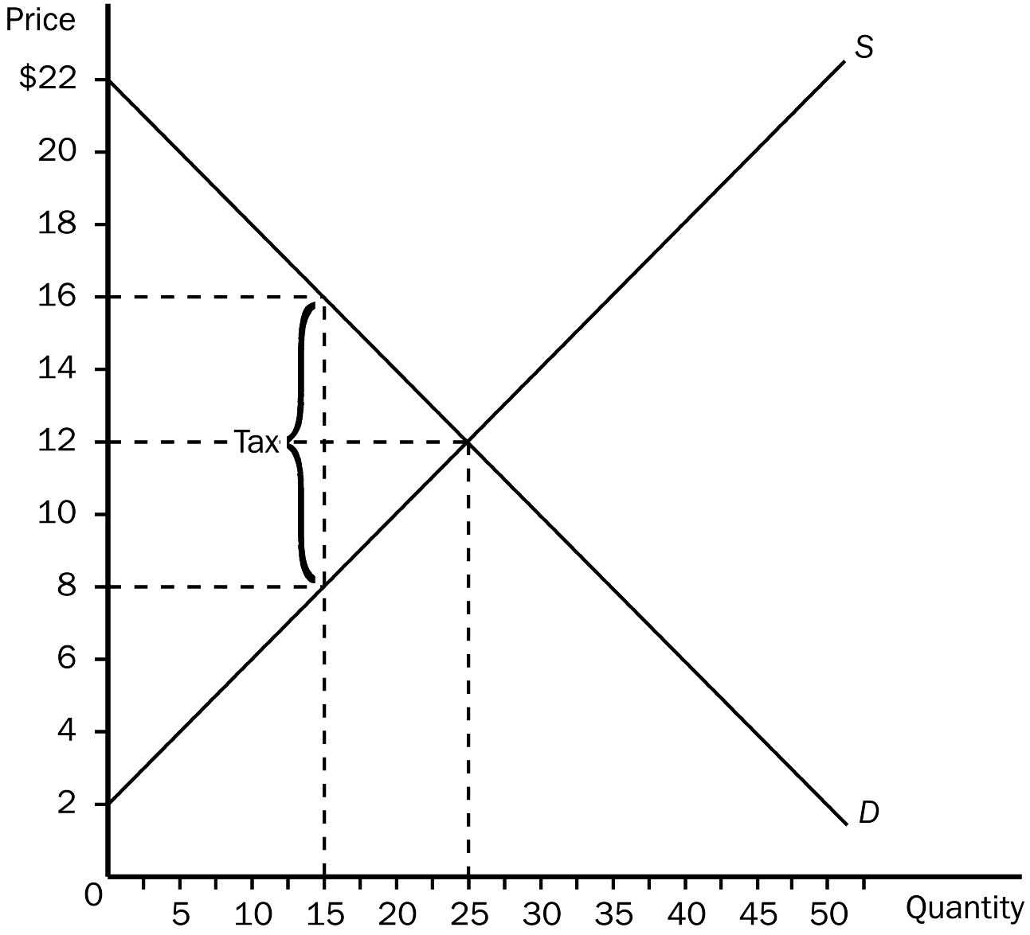
102. According to the graph, the equilibrium market price before the tax is imposed is
a. $16.
b. $12.
c. $8.
d. $4.
ANSWER: b. $12.
TYPE: M SECTION: 1 DIFFICULTY: 1
103. According to the graph, the price buyers pay after the tax is
a. $16.
b. $12.
c. $8.
d. $4.
ANSWER: a. $16.
TYPE: M SECTION: 1 DIFFICULTY: 2
104. According to the graph, the price sellers receive after the tax is
a. $16.
b. $12.
c. $8.
d. $4.
ANSWER: c. $8.
TYPE: M SECTION: 1 DIFFICULTY: 2
105. According to the graph, consumer surplus before the tax was levied equaled
a. $150.
b. $125.
c. $75.
d. $45.
ANSWER: b. $125.
TYPE: M SECTION: 1 DIFFICULTY: 3
106. According to the graph, producer surplus before the tax equaled
a. $150.
b. $125.
c. $75.
d. $45.
ANSWER: b. $125.
TYPE: M SECTION: 1 DIFFICULTY: 3
107. According to the graph, after the tax is levied, consumer surplus would be
a. $150.
b. $125.
c. $75.
d. $45.
ANSWER: d. $45.
TYPE: M SECTION: 1 DIFFICULTY: 3
108. According to the graph, after the tax is levied, producer surplus would be
a. $150.
b. $125.
c. $75.
d. $45.
ANSWER: d. $45.
TYPE: M SECTION: 1 DIFFICULTY: 3
109. According to the graph, the reduction in consumer surplus caused by the tax would be
a. $100.
b. $80.
c. $70.
d. $60.
ANSWER: b. $80.
TYPE: M SECTION: 1 DIFFICULTY: 3
110. According to the graph, the reduction in producer surplus caused by the tax would be
a. $100.
b. $80.
c. $70.
d. $60.
ANSWER: b. $80.
TYPE: M SECTION: 1 DIFFICULTY: 3
111. According to the graph, the benefits to the government (total tax revenue) would be
a. $150.
b. $120.
c. $100.
d. $80.
ANSWER: b. $120.
TYPE: M SECTION: 1 DIFFICULTY: 3
112. According to the graph, the total surplus before the tax would equal
a. $350.
b. $300.
c. $250.
d. $200.
ANSWER: c. $250.
TYPE: M SECTION: 1 DIFFICULTY: 3
113. According to the graph, the total surplus with the tax would equal
a. $240.
b. $230.
c. $220.
d. $210.
ANSWER: d. $210.
TYPE: M SECTION: 1 DIFFICULTY: 3
114. According to the graph, the amount of deadweight loss in this market resulting from the levying of the tax is
a. $20.
b. $30.
c. $40.
d. $50.
ANSWER: c. $40.
TYPE: M SECTION: 1 DIFFICULTY: 3

Assume that Tammy cleans Ryan’s house weekly for $80. Ryan would be willing to pay as much as $100 weekly to have his house cleaned. Tammy’s opportunity cost is $70.
115. If Tammy cleans Ryan’s house, his consumer surplus is
a. $100.
b. $80.
c. $70.
d. $20.
ANSWER: d. $20.
TYPE: M SECTION: 1 DIFFICULTY: 2
116. If Tammy cleans Ryan’s house, the producer surplus is
a. $100.
b. $80.
c. $70.
d. $10.
ANSWER: d. $10.
TYPE: M SECTION: 1 DIFFICULTY: 2
117. Assume that Ryan is required to pay a tax of $40 when he hires someone to clean his house. Which of the following is true?
a. Ryan will now clean his own home.
b. Tammy will continue to clean Ryan’s home but her producer surplus will decline.
c. Total economic welfare (consumer surplus plus producer surplus plus tax revenue) will increase.
d. Jane will continue to clean Ryan’s home, but consumer surplus will decline.
ANSWER: a. Ryan will now clean his own home.
TYPE: M SECTION: 1 DIFFICULTY: 2
118. Taxes cause deadweight losses because
a. they transfer purchasing power to the government which always wastes money.
b. they prevent buyers and sellers from realizing some of the gains from trade.
c. marginal buyers and sellers leave the market causing the quantity sold to fall.
d. Both b and c are correct.
ANSWER: d. Both b and c are correct.
TYPE: M SECTION: 1 DIFFICULTY: 3
119. Assume that a tax is levied on a good and that the government uses the revenue to clean up lethal toxic waste that would cause irreparable harm to a large number of people. In this case which of the following would NOT occur?
a. a decrease in consumer surplus to consumers of the taxed good
b. a decrease in producer surplus to producers of the taxed good
c. a probable increase in the total economic welfare of society
d. a decrease in the total economic welfare of society
ANSWER: d. a decrease in the total economic welfare of society
TYPE: M SECTION: 1 DIFFICULTY: 2
120. Assume that a tax is levied on a good and the government uses the funds to build statues of the Governors of each of the 50 states. In this case which of the following would NOT occur?
a. a decrease in consumer surplus to consumers of the taxed good
b. a decrease in producer surplus to producers of the taxed good
c. a probable decrease in the welfare of society that exceeds the deadweight loss from the tax
d. a deadweight loss larger than the loss in both consumer and producer surplus
ANSWER: d. a deadweight loss larger than the loss in both consumer and producer surplus
TYPE: M SECTION: 1 DIFFICULTY: 3

Sheila offers to do Stephanie’s housework for $20 per week. Stephanie’s opportunity cost of doing housework is $30 per week, and Sheila’s opportunity cost of doing housework is $10 per week.
121. What will be Stephanie’s gain in consumer surplus as a result of the proposed transaction?
a. Stephanie will gain $30 per week.
b. Stephanie will gain $20 per week.
c. Stephanie will gain $10 per week.
d. Stephanie will gain no consumer surplus.
ANSWER: c. Stephanie will gain $10 per week.
TYPE: M SECTION: 1 DIFFICULTY: 2
122. What will be Sheila’s gain in producer surplus as a result of the proposed transaction?
a. Sheila will gain $30 per week.
b. Sheila will gain $20 per week.
c. Sheila will gain $10 per week.
d. Sheila will gain no producer surplus.
ANSWER: c. Sheila will gain $10 per week.
TYPE: M SECTION: 1 DIFFICULTY: 2
123. The total gain in welfare due to the transaction described here is
a. $10 per week.
b. $20 per week.
c. $30 per week.
d. $40 per week.
ANSWER: b. $20 per week.
TYPE: M SECTION: 1 DIFFICULTY: 2
124. Oliver Wendell Holmes once said taxes
a. are the price we pay for a civilized society.
b. are a fact of life.
c. cannot be escaped unless you are in jail.
d. can only be avoided by the rich.
ANSWER: a. are the price we pay for a civilized society.
TYPE: M SECTION: 1 DIFFICULTY: 1
125. The deadweight economic loss from taxes
a. does not depend on tax rates.
b. is higher when tax rates are higher than when tax rates are lower.
c. is lower when tax rates are higher than when tax rates are lower.
d. does not depend on the slope of the demand curve.
ANSWER: b. is higher when tax rates are higher than when tax rates are lower.
TYPE: M SECTION: 2 DIFFICULTY: 2
126. The amount of deadweight loss from taxes depends on
a. the price elasticity of demand and supply.
b. how much of the tax revenue the government plans to spend.
c. the product the government is planning to tax.
d. All of the above are correct.
ANSWER: a. the price elasticity of demand and supply.
TYPE: M SECTION: 2 DIFFICULTY: 2
127. The size of the tax and the deadweight loss of a tax are
a. positively related.
b. negatively related.
c. independent of each other.
d. equal to each other.
ANSWER: a. positively related.
TYPE: M SECTION: 2 DIFFICULTY: 1
128. The greater the elasticities of demand and supply the
a. smaller the deadweight loss from a tax.
b. less intrusive a tax will be on a market.
c. greater the deadweight loss from a tax.
d. more equitable the distribution of a tax between buyers and sellers.
ANSWER: c. greater the deadweight loss of a tax.
TYPE: M SECTION: 2 DIFFICULTY: 2
129. If the supply of a good is relatively elastic, changing the price causes
a. a relatively small change in the amounts that buyers are willing to buy.
b. a relatively small change in the amounts sellers are willing to sell.
c. a relatively large change in the amounts sellers are willing to sell.
d. no change in the amounts sellers are willing to sell.
ANSWER: c. a relatively large change in the amounts sellers are willing to sell.
TYPE: M SECTION: 2 DIFFICULTY: 3
130. Assume that the demand for diamonds is more elastic than the demand for gasoline. Compared to the decline in purchases from a similar percentage tax on gasoline, we would expect that a tax on diamonds will cause the quantity of diamonds purchased to decline
a. more.
b. less.
c. the same.
d. neither more or less.
ANSWER: a. more.
TYPE: M SECTION: 2 DIFFICULTY: 2
131. Assume that the demand for diamonds is more elastic than the demand for gasoline. The tax levied on diamonds will cause the loss of consumer surplus to be
a. zero.
b. relatively large.
c. relatively small.
d. either small or large (depending on the elasticity of supply).
ANSWER: b. relatively large.
TYPE: M SECTION: 2 DIFFICULTY: 2
132. Assume that the demand for diamonds is more elastic than the demand for gasoline. A tax levied on gasoline will cause the loss of consumer surplus to be
a. zero (because raising the price of gasoline has no effect on the amount purchased).
b. relatively large.
c. relatively small.
d. either small or large--depending on the elasticity of supply.
ANSWER: c. relatively small.
TYPE: M SECTION: 2 DIFFICULTY: 2
133. Assume that the supply of gasoline is relatively inelastic and the supply of wheat is relatively elastic. Compared to the decline in quantity from a similar percentage tax on wheat, we would expect a tax on gasoline to cause the quantity of gasoline produced to
a. change more.
b. change less.
c. change by the same amount.
d. change either more or less, depending on the elasticity of demand.
ANSWER: b. change less
TYPE: M SECTION: 2 DIFFICULTY: 2
134. Assume that the supply of gasoline is relatively inelastic and the supply of wheat is relatively elastic. A tax levied on wheat will cause the loss of producer surplus to be
a. relatively large.
b. relatively small.
c. zero.
d. either small or large, depending on the elasticity of demand.
ANSWER: a. relatively large.
TYPE: M SECTION: 2 DIFFICULTY: 2
135. Assume that the demand for salt is relatively inelastic and that the demand for orange juice is relatively elastic. Compared to the deadweight loss from the same percentage tax on orange juice, the deadweight loss from imposing a tax on salt would be
a. greater.
b. less.
c. neither greater nor less.
d. either greater or less.
ANSWER: b. less.
TYPE: M SECTION: 2 DIFFICULTY: 2
136. Economists generally agree that the most important tax in the U.S. economy is
a. the income tax.
b. the tax on labor.
c. the inheritance or death tax.
d. corporate profit taxes.
ANSWER: b. the tax on labor
TYPE: M SECTION: 2 DIFFICULTY: 1
137. Concerning the labor market and taxes on labor, economists disagree
a. about the size of the deadweight loss.
b. that the marginal tax rate on labor is almost 50 percent.
c. about the elasticity of the labor supply curve.
d. All of the above.
e. Only a and c are correct.
ANSWER: e. Only a and c are correct.
TYPE: M SECTION: 2 DIFFICULTY: 2
138. The social security tax is primarily a tax on
a. earnings from labor.
b. interest income.
c. real estate holdings.
d. consumption spending.
ANSWER: a. earnings from labor.
TYPE: M SECTION: 2 DIFFICULTY: 1
139. If the labor supply curve is nearly vertical, a tax on labor
a. has a large deadweight loss.
b. will raise small amounts of tax revenue.
c. has little impact on the amount of work workers are willing to do.
d. Both b and c are correct.
ANSWER: c. has little impact on the amount of work workers are willing to do.
TYPE: M SECTION: 2 DIFFICULTY: 2
140. The marginal tax rate on labor income for many workers in the United States is almost
a. 30 percent.
b. 40 percent.
c. 50 percent.
d. 60 percent.
ANSWER: c. 50 percent.
TYPE: M SECTION: 2 DIFFICULTY: 1
141. The more mothers are pressured by society to be housekeepers and stay out of the labor force the
a. more elastic the supply of labor will be.
b. less elastic the supply of labor will be.
c. flatter the labor supply curve will be.
d. greater the reduction in output that will be caused by a tax on labor.
ANSWER: b. less elastic the supply of labor will be.
TYPE: M SECTION: 2 DIFFICULTY: 2
142. The more freedom people are given to choose the date of their retirement
a. more elastic the supply of labor.
b. less elastic the supply of labor.
c. steeper the labor supply curve.
d. smaller the reduction in output caused by a tax on labor.
ANSWER: a. more elastic the supply of labor.
TYPE: M SECTION: 2 DIFFICULTY: 2
143. Taxes on labor encourage all of the following EXCEPT
a. older workers to take early retirement from the labor force.
b. mothers to stay at home rather than work in the labor force.
c. workers to work overtime.
d. people to be paid under the table.
ANSWER: c. workers to work overtime.
TYPE: M SECTION: 2 DIFFICULTY: 1
144. Henry George argued that the government should raise
a. all of its revenue from taxes on labor.
b. most of its revenue from consumption taxes.
c. all of its revenue from a tax on land.
d. tax revenue from multiple and diverse taxes.
ANSWER: c. all of its revenue from a tax on land.
TYPE: M SECTION: 2 DIFFICULTY: 1
145. Since the amount of land is fixed, the total supply of land is
a. relatively elastic.
b. perfectly elastic.
c. perfectly inelastic.
d. relatively inelastic.
ANSWER: c. perfectly inelastic.
TYPE: M SECTION: 2 DIFFICULTY: 1
146. If the supply of land is fixed, a tax on land would be paid
a. entirely by the landowners.
b. entirely by the renters or users of the land.
c. partly by landowners and partly by land users.
d. only by workers.
ANSWER: a. entirely by the landowners.
TYPE: M SECTION: 2 DIFFICULTY: 2
147. A tax placed on land would cause
a. a huge deadweight loss.
b. no deadweight loss.
c. landlords to not bear any of the burden of the tax.
d. enough tax revenue so that all other taxes could be eliminated.
ANSWER: b. no deadweight loss.
TYPE: M SECTION: 2 DIFFICULTY: 2
148. Today’s property tax
a. taxes only the value of land.
b. is exactly the same as Henry George’s single tax proposal.
c. taxes land and the improvements to the land.
d. has no deadweight loss since the amount of revenue going to the government equals the reduction in the landowner’s surplus.
ANSWER: c. taxes land and the improvements to the land.
TYPE: M SECTION: 2 DIFFICULTY: 2
149. For Henry George’s single tax on land to not distort economic incentives, the tax would have to be on the value of
a. improved land.
b. commercial land.
c. unimproved land.
d. urban land.
ANSWER: c. unimproved land.
TYPE: M SECTION: 2 DIFFICULTY: 1
150. For Henry George’s land tax argument to be valid the land taxed must be
a. improved land.
b. productive land.
c. raw land.
d. urban land.
ANSWER: c. raw land.
TYPE: M SECTION: 2 DIFFICULTY: 1
151. One positive aspect of Henry George’s land tax is that
a. there is no deadweight loss.
b. the tax would fall equally on buyers and sellers.
c. the government would receive adequate revenue.
d. only the rich would be paying taxes.
ANSWER: a. there is no deadweight loss.
TYPE: M SECTION: 2 DIFFICULTY: 2
152. One negative aspect of Henry George’s land tax today would be that
a. the loss to landowners would be greater than the government revenue raised.
b. the deadweight loss would be much greater than that from other taxes.
c. the tax would not raise enough revenue to pay for government spending.
d. it would distort economic incentives.
ANSWER: c. the tax would not raise enough revenue to pay for government spending.
TYPE: M SECTION: 2 DIFFICULTY: 2
153. According to the famous economist Milton Friedman, the “least bad” tax is a tax on
a. income received from profits and interest.
b. the value of unimproved land.
c. labor income.
d. the value of land including the improvements to the land.
ANSWER: b. the value of unimproved land.
TYPE: M SECTION: 2 DIFFICULTY: 1
154. As the size of a tax increases the deadweight loss from the tax
a. declines.
b. remains constant.
c. increases.
d. No one knows how the deadweight loss changes because no tax has ever been reduced.
ANSWER: c. increases.
TYPE: M SECTION: 3 DIFFICULTY: 2
155. When the size of a tax is doubled, the deadweight loss from the tax
a. increases by the size of the tax.
b. doubles.
c. remains constant.
d. increases by a factor of four.
ANSWER: d. increases by a factor of four.
TYPE: M SECTION: 3 DIFFICULTY: 2
156. If the size of a tax is tripled, then the deadweight loss from the tax would
a. double.
b. triple.
c. increase a factor of six.
d. increase by a factor of nine.
ANSWER: d. increase by a factor of nine.
TYPE: M SECTION: 3 DIFFICULTY: 2
157. If the size of a tax increases, tax revenue will
a. increase.
b. decrease.
c. remain the same.
d. increase, then decrease.
ANSWER: d. increase, then decrease.
TYPE: M SECTION: 3 DIFFICULTY: 2
158. The Laffer curve
a. relates income tax rates to total income taxes collected.
b. was so ridiculous that economists took it as a joke, hence the name, Laffer Curve.
c. relates tax rates to deadweight welfare losses.
d. relates government welfare payments to the birth rate.
ANSWER: a. relates income tax rates to total income taxes collected.
TYPE: M SECTION: 3 DIFFICULTY: 2
159. Ronald Reagan believed that reducing income tax rates would
a. cause government tax collections to decline.
b. cause government tax collections to rise.
c. cause the Federal deficit (and the national debt) to increase.
d. have no effect on the amount of government tax collections.
ANSWER: b. cause government tax collections to rise.
TYPE: M SECTION: 3 DIFFICULTY: 2
160. One side-effect of the tax cuts made during Ronald Reagan’s terms as president was
a. increased tax revenues.
b. small budget surpluses.
c. large budget deficits.
d. decreased government spending.
ANSWER: c. large budget deficits.
TYPE: M SECTION: 3 DIFFICULTY: 1
161. Ronald Reagan obviously believed that the labor supply curve was
a. perfectly inelastic.
b. perfectly elastic.
c. relatively inelastic.
d. relatively elastic.
ANSWER: d. relatively elastic.
TYPE: M SECTION: 3 DIFFICULTY: 2
162. Ronald Reagan and Arthur Laffer both agreed that reducing income tax rates would
a. increase the national debt.
b. decrease government tax collections.
c. increase government tax collections.
d. not change the amount of revenue the government collected.
ANSWER: c. increase government tax collections.
TYPE: M SECTION: 3 DIFFICULTY: 2
163. The views held by Arthur Laffer and Ronald Reagan that cuts in tax rates would encourage people to increase the quantity of labor they supplied became known as
a. Laffer economics.
b. welfare economics.
c. supply-side economics.
d. microeconomics.
ANSWER: c. supply-side economics.
TYPE: M SECTION: 3 DIFFICULTY: 1
164. During Ronald Reagan’s first term in office, income tax rates were reduced significantly. The result was that
a. income tax collections declined.
b. income tax collections increased.
c. the Laffer curve was demonstrated to be essentially correct.
d. the government experienced budget surpluses for four consecutive years.
ANSWER: a. income tax collections declined.
TYPE: M SECTION: 3 DIFFICULTY: 1
165. The Laffer curve indicates each of the following EXCEPT income tax collections will be
a. very low if income tax rates are very low.
b. very low if income tax rates are very high.
c. at a maximum if income tax rates are at some intermediate level between very low and very high.
d. very high if income tax rates are very high.
ANSWER: d. very high if income tax rates are very high.
TYPE: M SECTION: 3 DIFFICULTY: 3
166. When a country is on the downward-sloping side of the Laffer curves, cutting tax rates will
a. lower tax revenues and increase deadweight loss.
b. lower both tax revenues and deadweight loss.
c. increase tax revenues and decrease deadweight loss.
d. increase both tax revenues and deadweight loss.
ANSWER: c. increase tax revenues and decrease deadweight loss.
TYPE: M SECTION: 3 DIFFICULTY: 2
167. If the government quadrupled the tax on gasoline, the deadweight loss from the gasoline tax would
a. more than quadruple.
b. quadruple.
c. increase, but it would not quadruple.
d. not change.
ANSWER: a. more than quadruple.
TYPE: M SECTION: 3 DIFFICULTY: 2
168. Studies indicate that if income tax rates in Sweden had been reduced, income tax collections would have
a. fallen.
b. risen.
c. remained constant.
d. risen, fallen, or remained constant (the studies were inconclusive).
ANSWER: b. risen.
TYPE: M SECTION: 3 DIFFICULTY: 1
169. The argument that cutting income tax rates will increase tax revenues
a. clearly has merit for the United States but not for most other countries.
b. clearly has merit for all countries that have income taxes.
c. may not have merit for the United States but has merit for most other countries.
d. is most likely to have merit for any country that has very high marginal tax rates.
ANSWER: d. is most likely to have merit for any country that has very high marginal tax rates.
TYPE: M SECTION: 3 DIFFICULTY: 2
170. The higher a country’s tax rates the more likely that country will be
a. on the top of the Laffer curve.
b. on the positively sloped part of the Laffer curve.
c. above the Laffer curve.
d. on the negatively sloped part of the Laffer curve.
ANSWER: d. on the negatively sloped part of the Laffer curve.
TYPE: M SECTION: 3 DIFFICULTY: 2
171. The “underground” economy refers to
a. mining and excavation.
b. illegal activities (such as prostitution and illegal drugs).
c. barter and other activities conducted “under the table” to avoid being taxed.
d. All of the above are correct.
e. Both b and c are correct.
ANSWER: d. Both b and c are correct.
TYPE: M SECTION: 3 DIFFICULTY: 2
172. Tax cuts and deregulation may cause output in an economy to increase because of all of the following EXCEPT
a. increasing the value of output by reducing deadweight tax burdens.
b. luring the underground economy to the surface.
c. increasing incentives to produce.
d. reducing competition.
ANSWER: d. reducing competition.
TYPE: M SECTION: 3 DIFFICULTY: 2
173. A major political problem with collecting taxes to finance government spending is that
a. taxes make taxpayers worse off since government spending benefits no one.
b. taxes make taxpayers worse off since government spending benefits only those on welfare.
c. the people who pay the taxes are often not the same people who benefit from the government spending of tax funds.
d. taxes reduce economic welfare more than the expenditure of tax funds benefits society.
ANSWER: c. the people who pay the taxes are often not the same people who benefit from the government spending of tax funds.
TYPE: M SECTION: 3 DIFFICULTY: 2
174. A tax of $10 per unit is imposed on a certain market. The tax reduces the equilibrium quantity in the market by 200 units. The deadweight loss from the tax is
a. $2000.
b. $1000.
c. $500
d. There is not enough information to answer the question.
ANSWER: b. $1000.
TYPE: M SECTION: 1 DIFFICULTY: 2
175. Suppose that the equilibrium quantity in the market for widgets has been 200 per month. Then a tax of $5 per widget is imposed on widgets. As a result, the government is able to raise $750 per month in revenue. We can conclude that the equilibrium quantity of widgets has fallen by
a. 25 per month.
b. 50 per month.
c. 75 per month.
d. 100 per month.
ANSWER: b. 50 per month.
TYPE: M SECTION: 1 DIFFICULTY: 2
176. Suppose that the equilibrium quantity in the market for widgets has been 200 per month. Then a tax of $5 per widget is imposed on widgets. The price paid by buyers increases by $2 and the after-tax price received by sellers falls by $3. The government is able to raise $750 per month in revenue from the tax. The deadweight loss from the tax is
a. $250.
b. $125.
c. $75.
d. $50.
ANSWER: b. $125.
TYPE: M SECTION: 1 DIFFICULTY: 3
177. Suppose that policymakers are considering placing a tax on either of two markets. In Market A, the tax will have a significant effect on the price consumers pay, but it will not affect equilibrium quantity very much. In Market B, the same tax will have only a small effect on the price consumers pay, but it will have a large effect on the equilibrium quantity. In which market will the tax have a larger deadweight loss?
a. Market A
b. Market B
c. Deadweight loss will be the same in both markets.
d. There is not enough information to answer the question.
ANSWER: b. Market B
TYPE: M SECTION: 2 DIFFICULTY: 3
178. Suppose that the equilibrium quantity in the market for widgets has been 200 per month. Then a tax of $5 per widget is imposed on widgets. As a result, the government is able to raise $750 per month in revenue. But at the same time, an underground market in widgets is created which did not previously exist. The government uses the funds raised in the legal widget market to completely suppress the underground widget market. The action has no effect on the legal market; the government still collects $750 per month in revenue. By itself, the government’s crackdown on the underground market
a. increased the deadweight loss to society from the widget tax.
b. decreased the deadweight loss to society from the widget tax.
c. had no effect on the deadweight loss to society from the widget tax.
d. might have increased, decreased or had no effect on the deadweight loss to society from the widget tax.
ANSWER: a. increased the deadweight loss to society from the widget tax.
TYPE: M SECTION: 1 DIFFICULTY: 3
179. Which of the following would likely have the smallest deadweight loss?
a. a head tax (i.e., a tax everyone must pay regardless of what one does or buys)
b. an income tax
c. a tax on compact discs
d. a tax on caviar
ANSWER: a. a head tax (i.e., a tax everyone must pay regardless of what one does or buys)
TYPE: M SECTION: 2 DIFFICULTY: 3
180. As more people become self-employed and so can determine how many hours they work per week, we would expect that the deadweight loss from the Social Security Tax would
a. increase and the revenue generated from it would rise.
b. decrease and the revenue generated from it would rise.
c. increase and the revenue generated from it would fall.
d. decrease and the revenue generated from it would fall.
ANSWER: c. increase and the revenue generated from it would fall.
TYPE: M SECTION: 2 DIFFICULTY: 3
181. Nobel Prize-winning economist Milton Friedman said that, “In my opinion, the least bad tax is the property tax on the unimproved value of land.” Why?
a. Land owners can afford the tax better than other people.
b. A tax on unimproved land would be sufficient to fund government, so all other taxes could be abolished.
c. Such a tax could generate more government revenue than any tax on labor or capital.
d. A tax on unimproved land would have no deadweight loss.
ANSWER: d. A tax on unimproved land would have no deadweight loss.
TYPE: M SECTION: 2 DIFFICULTY: 2
182. Which of the following statements is true for most markets?
a. As the tax rate increases, tax revenue continually rises and deadweight loss continually falls.
b. As the tax rate rises, tax revenue rises for a while, but eventually begins to fall; deadweight loss rises but also begins to fall as tax revenue falls.
c. As the tax rate rises, tax revenue rises for a while, but eventually begins to fall; deadweight loss continually rises.
d. As the tax rate rises, tax revenue rises for a while, but eventually begins to fall; deadweight loss falls for a while, but begins to rise as tax revenue falls.
ANSWER: c. As the tax rate rises, tax revenue rises for a while, but eventually begins to fall; deadweight loss continually rises.
TYPE: M SECTION: 3 DIFFICULTY: 2
183. Which of the following ideas is the most plausible?
a. Reducing a high tax rate is less likely to increase tax revenue than reducing a low tax rate.
b. Reducing a high tax rate is more likely to increase tax revenue than reducing a low tax rate.
c. Reducing a high tax rate will have the same effect on tax revenue as reducing a low tax rate.
d. Reducing a tax rate can never increase tax revenue.
ANSWER: b. Reducing a high tax rate is more likely to increase tax revenue than reducing a low tax rate.
TYPE: M SECTION: 3 DIFFICULTY: 3
TRUE/FALSE
1. Normally, both buyers and sellers are worse off when a good is taxed.
ANSWER: T TYPE: T SECTION: 1
2. Often, the tax revenue collected by the government equals the reduced welfare of buyers and sellers caused by the tax.
ANSWER: F TYPE: T SECTION: 1
3. A tax places a wedge between the price buyers pay and the price sellers receive.
ANSWER: T TYPE: T SECTION: 1
4. A tax on a good causes the size of the market to increase.
ANSWER: F TYPE: T SECTION: 1
5. A tax raises the price received by sellers and lowers the price paid by buyers.
ANSWER: F TYPE: T SECTION: 1
6. When a tax is imposed, the loss of consumer surplus and producer surplus as a result of the tax exceeds the revenue raised by the government.
ANSWER: T TYPE: T SECTION: 1
7. Because taxes distort incentives, they cause markets to allocate resources inefficiently.
ANSWER: T TYPE: T SECTION: 1
8. Taxes cause deadweight losses because they prevent buyers and sellers from realizing some of the gains from trade.
ANSWER: T TYPE: T SECTION: 1
9. The more inelastic the demand and supply curves, the greater the deadweight loss of a tax.
ANSWER: F TYPE: T SECTION: 2
10. If the supply curve is more elastic, ceteris paribus, the deadweight loss from a given tax will be larger.
ANSWER: T TYPE: T SECTION: 2
11. If a tax did not induce buyers or sellers to change their behavior, it would not cause a deadweight loss.
ANSWER: T TYPE: T SECTION: 2
12. The most important tax in the U.S. economy is the corporate profit tax.
ANSWER: F TYPE: T SECTION: 2
13. The Social Security tax, and to a large extent, the federal income tax, are labor taxes.
ANSWER: T TYPE: T SECTION: 2
14. Economists disagree on whether labor taxes have a small or a large deadweight loss.
ANSWER: T TYPE: T SECTION: 2
15. A tax on unimproved land falls entirely on landowners, because the supply of land is perfectly inelastic.
ANSWER: T TYPE: T SECTION: 2
16. Because the supply of land is perfectly elastic, the deadweight loss of a tax on land is enormous.
ANSWER: F TYPE: T SECTION: 2
17. The demand for bread is less elastic than the demand for donuts; hence, a tax on bread will create a larger deadweight loss than will the same tax on donuts, ceteris paribus.
ANSWER: F TYPE: T SECTION: 2
18. The larger the deadweight loss from taxation, the larger the cost of any government program.
ANSWER: T TYPE: T SECTION: 2
19. A tax on insulin is likely to cause a tremendous deadweight loss to society.
ANSWER: F TYPE: T SECTION: 2
20. The deadweight loss of a tax rises even more rapidly than the size of the tax.
ANSWER: T TYPE: T SECTION: 3
21. As the size of a tax increases, the government’s tax revenue rises, then falls.
ANSWER: T TYPE: T SECTION: 3
22. If the size of a tax doubles, the deadweight loss rises by a factor of six.
ANSWER: F TYPE: T SECTION: 3
23. Although tax revenue eventually begins to fall as tax rates increase, the revenue will always be greater than zero, no matter how large the tax is.
ANSWER: F TYPE: T SECTION: 3
24. Economist Arthur Laffer made the argument that tax rates in the United States were so high that reducing the rates would increase tax revenue, ceteris paribus.
ANSWER: T TYPE: T SECTION: 3
25. The Laffer curve is the curve showing how tax revenue varies as tax rates vary.
ANSWER: T TYPE: T SECTION: 3
26. The result of the large tax cuts in the first Reagan Administration demonstrated that Arthur Laffer was right in his contention that reducing tax rates would increase tax revenues.
ANSWER: F TYPE: T SECTION: 3
27. The more elastic the supply and demand curves in a market, the more taxes in that market distort behavior, and the more likely it is that a tax cut will raise tax revenue.
ANSWER: T TYPE: T SECTION: 3
28. When the government imposes taxes on buyers and sellers of a good, society loses some of the benefits of market efficiency.
ANSWER: T TYPE: T SECTION: 4

SHORT ANSWER
1.
Using the graph shown, determine each of the following:
a. equilibrium price before the tax
b. consumer surplus before the tax
c. producer surplus before the tax
d. total surplus before the tax
e. consumer surplus after the tax
f. producer surplus after the tax
g. total tax revenue to the government
h. total surplus (consumer surplus + producer surplus + tax revenue) after the tax
i. deadweight loss
ANSWER:
a. $10
b. $3600
c. $2400
d. $6000
e. $900
f. $600
g. $3000
h. $4500
i. $1500
TYPE: S SECTION: 1
2. John has been in the habit of mowing Willa’s lawn each week for $20. John’s opportunity cost is $15, and Willa would be willing to pay $25 to have her lawn mowed. What is the maximum tax the government can impose on lawn mowing without discouraging John and Willa from continuing their mutually beneficial arrangement?
ANSWER: If the tax is less than $10, there will exist a price at which both John and Willa will still benefit from the lawn-mowing arrangement. If the tax is $10, a price can be set which will leave John and Willa neither better off nor worse off from the lawn-mowing arrangement. If the tax is greater than $10, all possible prices will leave at least one of the parties worse off from the lawn-mowing arrangement.
TYPE: S SECTION: 1
3. 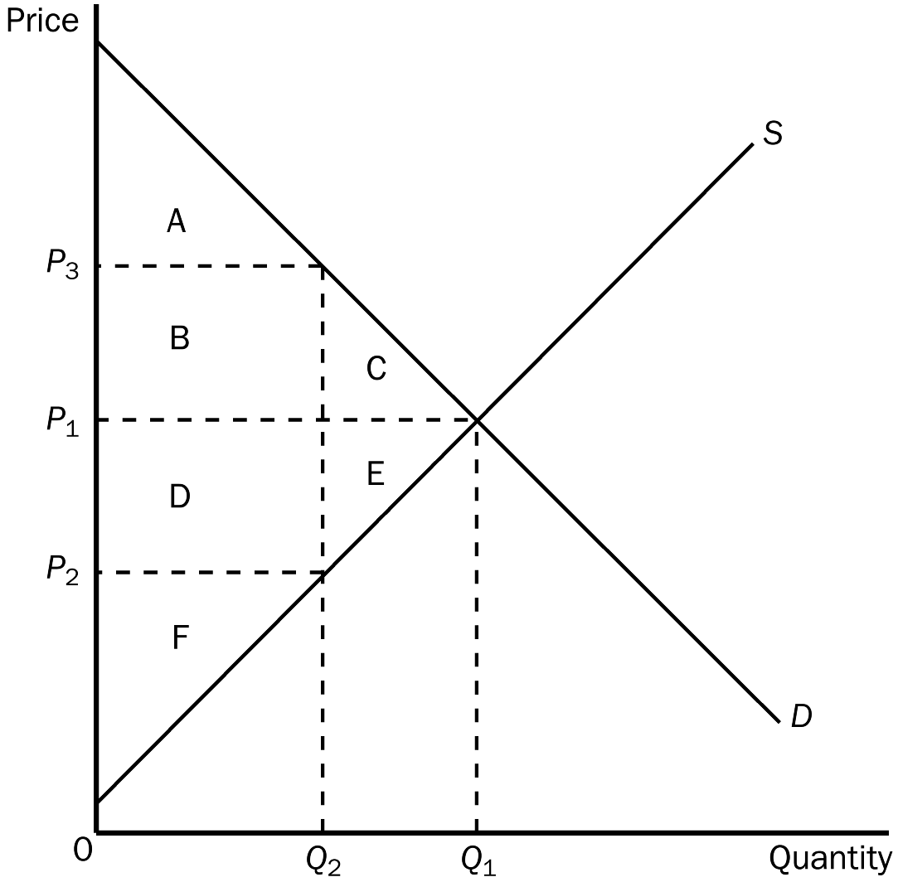
Use the graph shown to fill in the following table.

 | WITHOUT TAX | WITH TAX | CHANGE
Consumer surplus
Producer surplus
Tax revenue
Total surplus

ANSWER:
 | WITHOUT TAX | WITH TAX | CHANGE
Consumer surplus | A + B + C | A | –(B + C)
Producer surplus | D + E + F | F | –(D + E)
Tax revenue | None | B + D | (B + D)
Total surplus | A + B + C + D + E + F | A + B + D + F | –(C + E)
TYPE: S SECTION: 1
4. Suppose that instead of a supply-demand diagram, you are given the following information:
Q_{s} = 100 + 3P
Q_{d} = 400 – 2P
From this information compute equilibrium price and quantity. Now suppose that a tax is placed on buyers so that
Q_{d} = 400 – (2P + T).
If T = 15, solve for the new equilibrium price and quantity. (Note: P is the price received by sellers and P + T is the price paid by buyers.) Compare these answers for equilibrium price and quantity with your first answers. What does this show you?
ANSWER: Prior to the tax, the equilibrium price would be $60 and the equilibrium quantity would be 280. After the tax is imposed, P, the price received by sellers would be $57. The price paid by buyers would be $72. The quantity sold would be 271. The new answer shows three obvious facts. First, buyers pay more with a tax and second, sellers receive less with a tax. The third thing is that the size of the market shrinks when a tax is imposed on a product.
TYPE: S SECTION: 1
5. Using demand and supply diagrams, show the difference in deadweight loss between a market with inelastic demand and supply curves and a market with elastic demand and supply curves.
ANSWER: 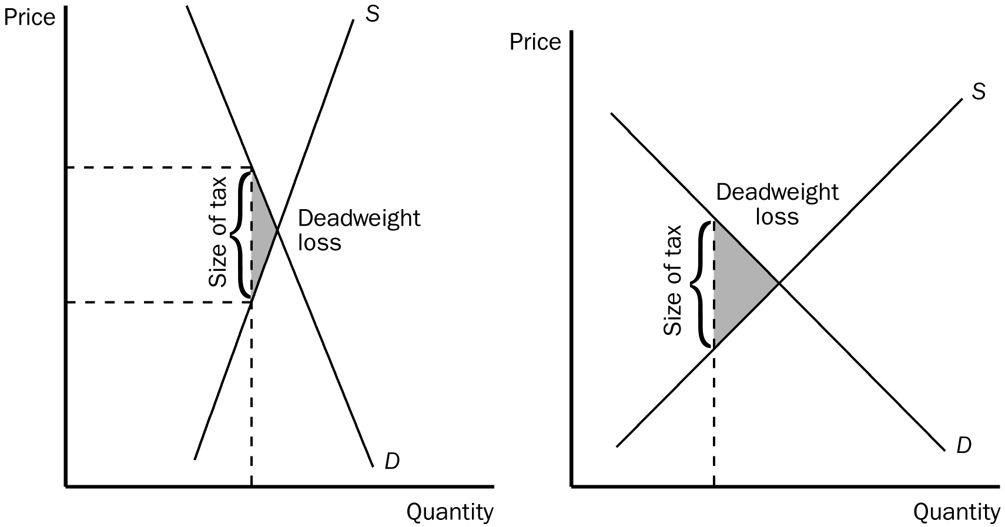
TYPE: S SECTION: 2
6. Illustrate on three demand and supply graphs how the size of a tax (small, medium and large) can alter total revenue and deadweight loss.
ANSWER: 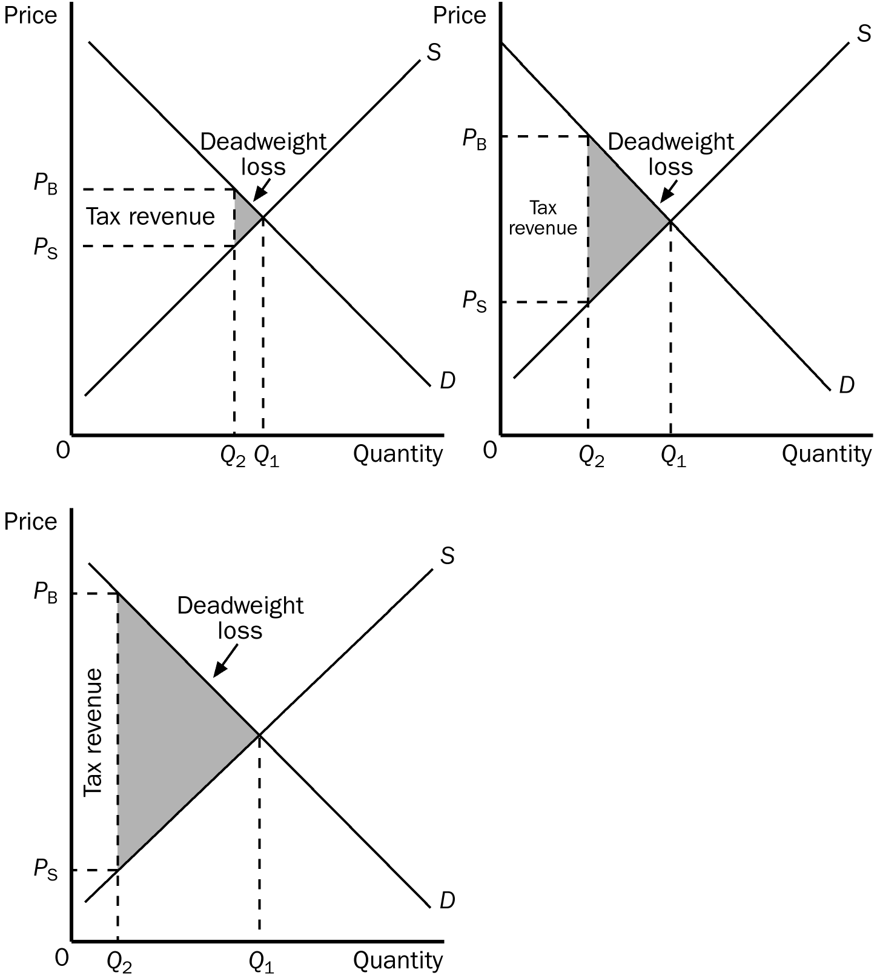
TYPE: S SECTION: 2

